**Date:** Monday, December 14, 2015, 3:00 pm to 4:00 pm ET

**Attendees:**

Participants invited/participated listed at the conclusion of this document (*participants shown in gray highlight)*.

**Scope of Work Group:**

* Pipeline Risk Modeling for Gas Transmission and Hazardous Liquid Pipelines
* Development of a pipeline system risk modeling technical guidance document
* Forum to obtain the combined perspective of industry, regulators, risk services providers, and the public.

**Meeting Action Items:**

|  |  |  |  |
| --- | --- | --- | --- |
| **Item** | **Description** | **Responsible** | **Complete** |
| 1 | Define group mission statement.   * Need volunteers to help develop Mission Statement. | Dane Spillers |  |
| 2 | Distribute applicable NTSB recommendations to the group. | Steve Nanney | Included Attachment 2 |
| 3 | Confirm CenterPoint hosting of the first physical meeting in Houston, February 8-9, 2016. | Mark Clayton | Confirmed |
| 4 | Review conference call PowerPoint points of input prior to January 12, 2016 group conference call, **submit recommendations prior to January 12 call**, and be prepared to provide input for:   * risk modeling topics * operator “best practices” * service provider input   Develop agenda for February 8-9 meeting | All |  |
| 5 | January 12, 2016 work group conference call (3 to 4:30 pm ET) | All | Scheduled |
| 6 | February 8-9 work group physical meeting in Houston. | All | Scheduled |

**Conference Call Agenda for Monday, December 14:**

*The call generally followed the meeting PowerPoint (Attachment 1). Additional specific notes are provided below in italics. Action items are indicated by **.*

1. Introductions
2. Work Scope (*draft work scope/road map provided to conference call participants)*
   1. *Mission Statement for the group to be developed. ** Dane Spillers to take the lead on defining this statement; input requested from non-PHMSA participants* ***(volunteers to work on Mission Statement need to contact Dane S.)****.*
   2. *Summary of applicable NTSB recommendations? ** Yes, PHMSA will distribute to work group participants. [Note: Action completed by including NTSB Recommendations as Attachment 2 to this document.]*
3. Road Map/Timeline (*draft provided to conference call participants; see Attachment 3*)
4. When do we involve “other participants” in the Work Group and Whom?
   1. *A spreadsheet of risk modeling abstracts submitted to PHMSA prior to the September 2015 Risk Modeling Workshop was provided to the work group prior to the conference call. [Not all abstracts were invited to present at the meeting. Presentations given at the September 2015 Risk Modeling Workshop can be viewed at: http://primis.phmsa.dot.gov/meetings/MtgHome.mtg?mtg=104]*
   2. *Individual operators may also desire to share specific modeling approaches.[Work group members need to suggest topics before or during the January 12 meeting for consideration at the February in-person meeting, such as: best modeling approach methods, topics from Operators (best practices), modeling systems from service providers, etc.]*
5. Topics and participants for late-January or early-February, 2016 Meeting

* Submit topics and presenters to invite to January/February meeting
* Conference Call – selected January 12, 3 to 4:30 pm ET to select topics and presenters – [Please send any suggests prior to or during the January 12 meeting.]

1. Next Conference Call – week of January 11, 2016? \*\**Participant discussion indicated January 12, 2016 is a good date for the next call; mid-afternoon time slot should work.*
2. Location *and Date* of *First Work Group Physical* Meeting
   1. *PHMSA leaning to the weeks of 2/8/2016 or 2/15/2016. CenterPoint Energy offered to host the meeting at their offices in Houston (** Mark Clayton to confirm). Group discussion indicated either week would work, with a preference for the 2/8/2016 week.* ***\*\* Discussion indicated meeting to be scheduled to start on noon Monday, 2/8/16, concluding on Tuesday afternoon, 2/9/16 at CenterPoint Energy in Houston****.*
   2. *Meeting duration? Group discussion indicated a general preference for a 2-day meeting allowing for morning travel on day 1 and concluding the afternoon of day 2.*
   3. *Meeting equipment? Basic whiteboard/LCD projector/screen equipment and capability for participants to call in remotely.*
3. Meeting Action Items – above for details

**Participants:**

|  |  |  |
| --- | --- | --- |
| Pipeline Risk Modeling Work Group Conference Call; December 14, 2015 (gray highlight indicates were present) | | |
|  | **Name** | **Company** |
|  | Toby Fore | Kinder Morgan |
|  | Matt Nicholson | Columbia Gas |
|  | Wendy Wagster | INGAA |
|  | Mark Hereth | INGAA |
|  | Peter Chace | PUC of Ohio (NAPSR) |
|  | Steve Allen | URC of Indiana (NAPSR) |
|  | Erin Kurilla | AGA |
|  | Mark Clayton | CenterPoint Energy |
|  | Jacob Steere | Consumers Energy |
|  | Pranab Samanta | Brookhaven National Laboratory |
|  | Mason Matthews | Athens Utilities Gas (APGA) |
|  | Bob Youngblood | Idaho National Laboratory |
|  | Stuart Saulters | API |
|  | Chris Foley | Phillips 66 |
|  | Jill Watson | Marathon |
|  | Pat Westrick | Marathon |
|  | Mark Piazza | Colonial |
|  | Vinnie Holohan | PHMSA |
|  | Chris McLaren | PHMSA |
|  | Dane Spillers | PHMSA |
|  | Steve Nanney | PHMSA |
|  | **“Alternate and Support Participants”** | |
|  | John Erickson (Alt.) | APGA |
|  | Kenneth Lee | PHMSA |
|  | Martin Sattison (Alt.) | Idaho National Laboratory |
|  | David Kuhtenia | Cycla (PHMSA) |

**Attachment 1 – December 14, 2015 Meeting PowerPoint**

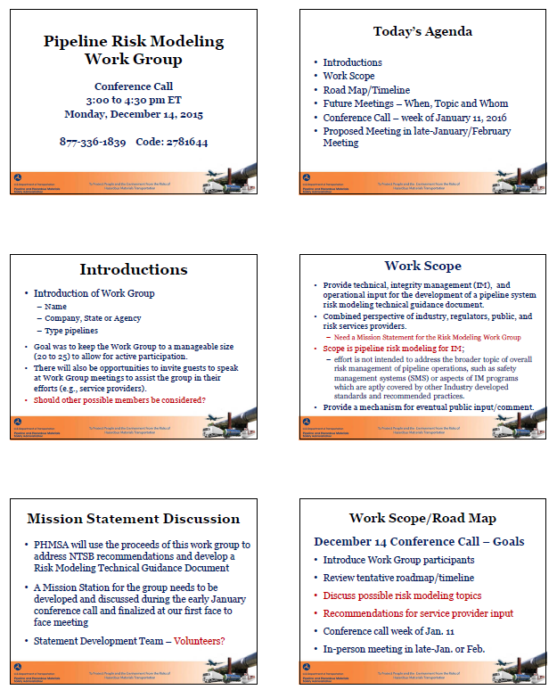

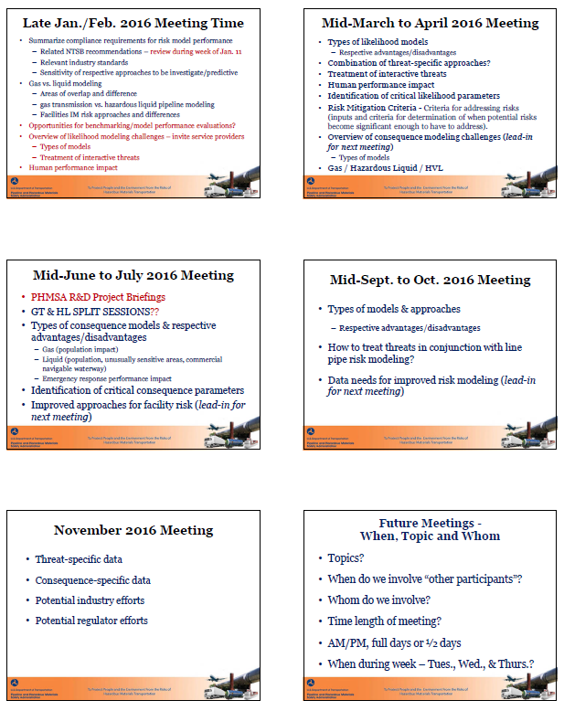

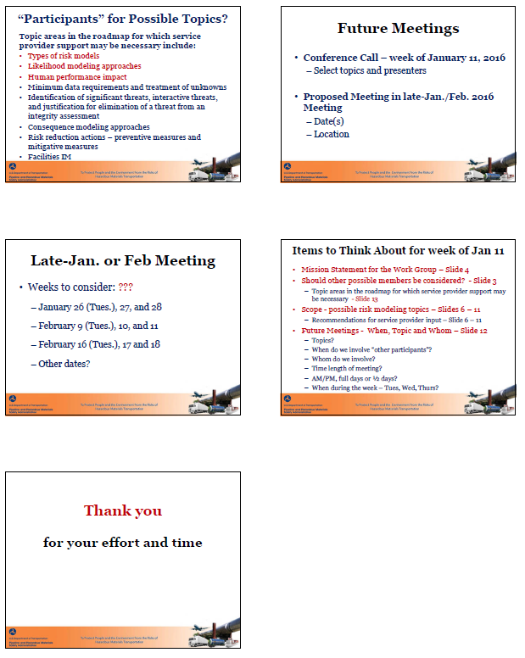

**Attachment 2 – NTSB Recommendations (specific recommendations applicable to the RMWG shown in “yellow highlight”)**

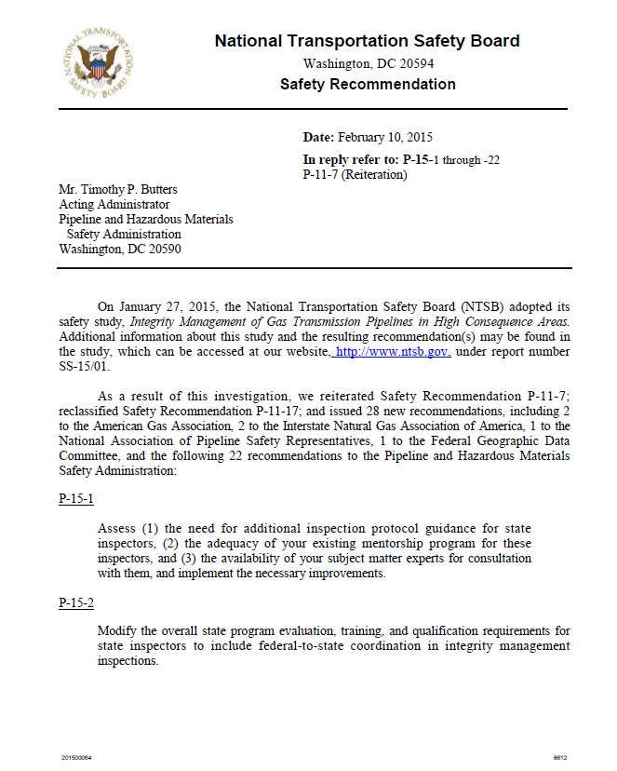

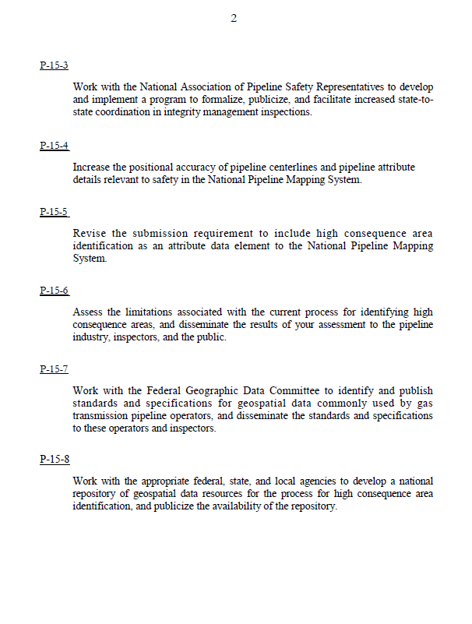

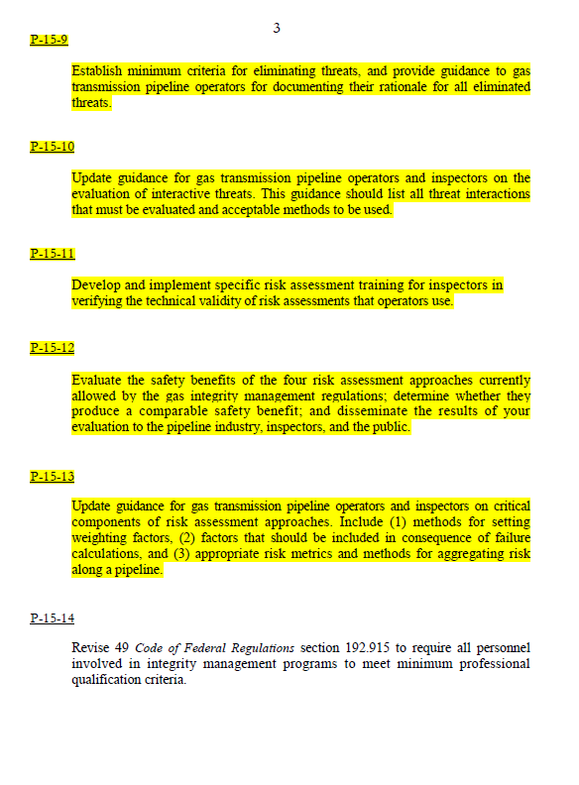

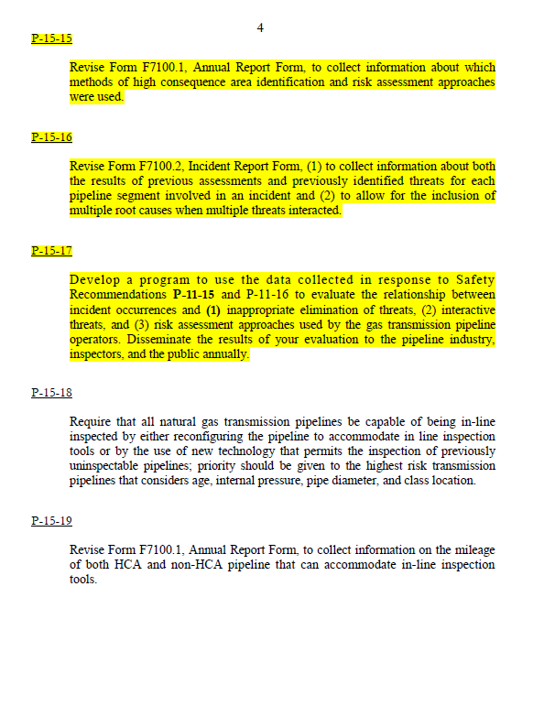

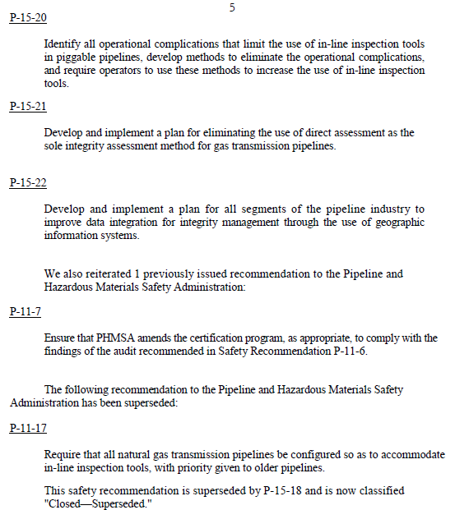 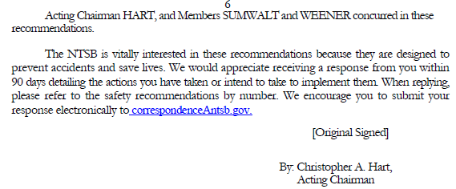

**Additional applicable NTSB recommendations are excerpted from NSTB Safety Recommendation dated September 26, 2011.**

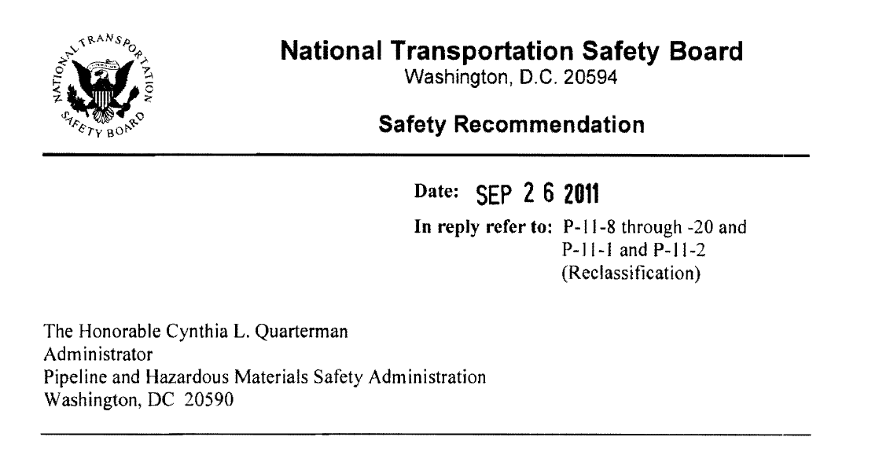

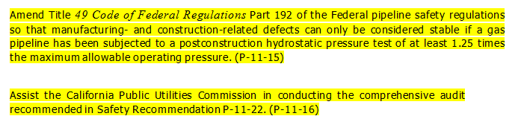

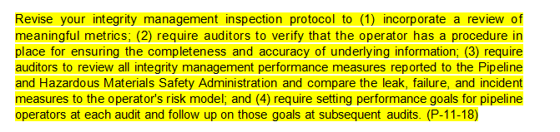

**Attachment 3 – Draft RMWG Scope/Roadmap (draft 11/25/2015)**

**Risk Modeling Work Group**

**Work Scope**

* Provide technical, integrity management and operational input to PHMSA to aid in the development of a pipeline system risk modeling technical guidance document.
* Provide a forum to obtain the combined perspective of industry, regulators, public, and risk services providers.
  + Note: PHMSA is seeking a wide range of input and consensus as part of the development of this technical guidance, both from within, and from applicable stakeholders. Final work group product(s) will utilize a “round robin” type of review process that includes all participants, with PHMSA reserving the final edit rights.
* Provide a mechanism for eventual public input/comment.
* Specifically limit scope to risk modeling; this effort is not intended to address the broader topic of overall risk management of pipeline operations, such as safety management systems (SMS) or all aspects of integrity management programs which are aptly covered by other Industry developed standards and recommended practices.

**Roadmap/Timeline**

| **Activity** | **Details** | **Timeline** |
| --- | --- | --- |
| Establish Work Group participants | * Goal is to keep the Work Group to a manageable size (20 to 25) to allow for active participation and still allow work to progress in a timely fashion. A proposed breakdown of work group members that mirrors the structure utilized by consensus standards bodies:   + 1 – Pipeline Safety Trust   + 1 – NTSB   + 5 – PHMSA   + 2 – NAPSR   + 3 – AGA + 2 Members ( 4-5 nominees, PHMSA to select)   + 3 – INGAA + 2 Members (4-5 nominees, PHMSA to select)   + 3 – API + 2 Members (4-5 nominees, PHMSA to select)   + 1 – APGA   + 2 – National Labs (Idaho, Brookhaven)   + 1 – Work Group support * There will also be opportunities to invite guests to speak at Work Group meetings to assist the group in their efforts (e.g., service providers). | November 2015 |
| Initial Work Group Introductory Conference Call | * Establish PHMSA goal(s) for the Work Group * Introduce Work Group participants * Review tentative roadmap/timeline * Industry recommendations for service provider input and specific topics to present (PHMSA to select) * After this call will schedule conference call with Service Providers – mid December or early January | December 2015 |
| Initial Work Group Physical Meeting | * Summarize compliance requirements for risk model performance   + Related NTSB recommendations   + Relevant industry standards   + Need for sensitivity of respective approaches to be investigate/predictive * Gas vs. liquid modeling   + Areas of overlap   + Areas of difference   + gas transmission vs. hazardous liquid pipeline modeling   Note: gas distribution pipeline modeling not included at this time   * + Facilities IM risk approaches and differences * Opportunities for benchmarking/model performance evaluations? * Overview of likelihood modeling challenges (*lead-in for next meeting*) – invite service providers to present (select presenters)   + Types of models   + Treatment of interactive threats   + Human performance impact | Late January 2016 or early February 2016 |
| Improved Approaches for Likelihood Modeling Meeting | * Types of likelihood models   + Respective advantages/disadvantages * Combination of threat-specific approaches? * Treatment of interactive threats * Human performance impact * Identification of critical likelihood parameters * Risk Mitigation Criteria - Criteria for addressing risks (inputs and criteria for determination of when potential risks become significant enough to have to address). * Overview of consequence modeling challenges (*lead-in for next meeting*)   + Types of models   + Gas / Hazardous Liquid / HVL | Mid-March to Mid-April 2016 |
| PHMSA R&D Project Briefings  - - - - - - - - - - - - -  GT & HL SPLIT SESSIONS –  Improved Approaches for Consequence Modeling Meetings | * PHMSA R&D Project Briefings   - - - - - - - - - - - - - - - - - - - - - - - - - - - - - - - - - - - - - - - - - - - - - - - -  GT & HL SPLIT SESSIONS   * Types of consequence models & respective advantages/disadvantages   + Gas (population impact)   + Liquid (population, unusually sensitive areas, commercial navigable waterway)   + Emergency response performance impact * Identification of critical consequence parameters * Improved approaches for facility risk (*lead-in for next meeting*) | Mid-June to Mid-July 2016 |
| Improved Approaches for Facility Risk Meeting | * Types of models & approaches   + Respective advantages/disadvantages * How to treat threats in conjunction with line pipe risk modeling? * Data needs for improved risk modeling (*lead-in for next meeting*) | Mid-September to Mid-October 2016 |
| Data Needs for Improved Risk Modeling Meeting | * Threat-specific data * Consequence-specific data * Potential industry efforts * Potential regulator efforts | November 2016 |
| Work Group Conclusions and Recommendations to PHMSA Meeting | * Summary of the four key areas of evaluation – * Likelihood, Consequence, Facility, and Data * Conclusions * Recommendations | Mid-January to Mid-February 2017 |
| Concluding Public Workshop | * Summary of the four key areas of evaluation * Likelihood, Consequence, Facility, Data Needs and Quality * Work Group Conclusions * Work Group Recommendations * R&D project presentations * Discussion of “next steps” by industry, public | March 2017 |
| Risk Modeling Guidance Document Issuance | * PHMSA pipeline system risk modeling technical guidance document   + Posted to public web site   + Anticipated review/update cycle | Mid-April to Mid-May 2017 |