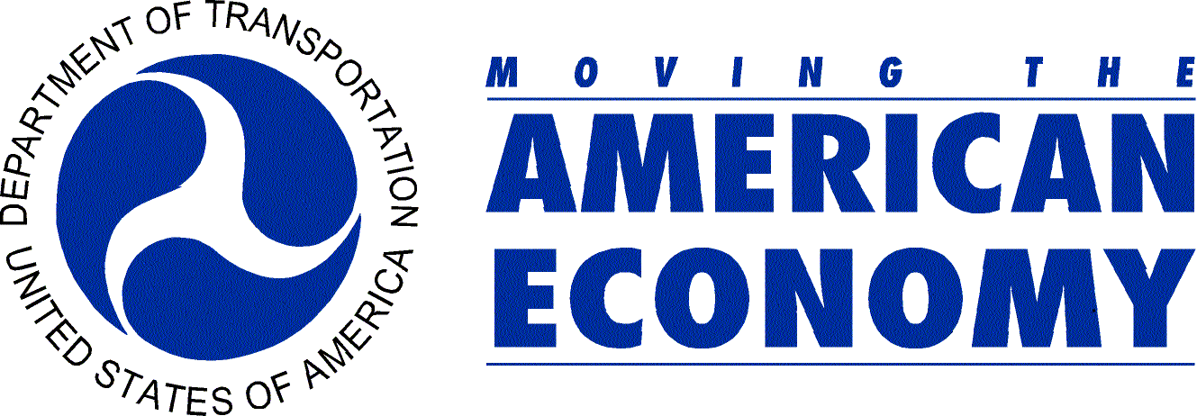 | U.S. Department of Transportation  Office of Public Affairs  Washington, D.C.  www.dot.gov/affairs/briefing.htm

News

PHMSA 1-06 Contact: James Wiggins (202) 366-4978
Monday, April 10, 2006 Damon Hill (202) 366-4424
Office Tel.: (202) 366-4831
Federal Pipeline Safety Agency Reaches Agreement with Kinder Morgan to Address Integrity Threats and Increased Rate of Incidents

The Pipeline and Hazardous Materials Safety Administration (PHMSA) today announced it has reached an agreement with Kinder Morgan Energy Partners over systemwide safety upgrades in six Western states. This agreement between federal regulators and Kinder Morgan followed several pipeline accidents and is expected to result in up to $90 million worth of safety improvements.

The agreement covers the 3,900-mile Kinder Morgan’s Pacific Operations unit in Arizona, California, Nevada, New Mexico, Oregon and west Texas. The Pacific Operations unit includes the CALNEV and Santa Fe Pacific Pipelines and associated bulk terminals, but does not include the Carbon Dioxide or Cypress systems. The improvements include those made in response to an Aug. 24, 2005 PHMSA order that required Kinder Morgan to evaluate the safety and reliability of its pipelines.

PHMSA will require Kinder Morgan to review all accidents occurring on its Pacific Operations system since March 31, 2001 and identify and repair any existing or potential safety threats. The agreement also requires the company to improve its methods for inspecting the interior of pipelines, including the use of improved technology to better locate damage caused by outside forces. In addition, Kinder Morgan will be required to evaluate its effectiveness in controlling pipeline corrosion, and to submit for PHMSA approval its procedures for preventing damage through “one-call” centers that determine if a pipeline is located where excavation is taking place. PHMSA incorporated into the agreement an innovative penalty structure that will subject Kinder Morgan to fines ranging from $1,000 to $10,000 per day if it fails to comply with the agreement.

“Companies have an obligation to maintain and ensure the safety of their systems,” said PHMSA Acting Administrator Brigham A. McCown. “Kinder Morgan has made a significant commitment to safety under this agreement,” he said.

Recent PHMSA accident investigations and reviews of Kinder Morgan’s operations prompted the agency’s August order. PHMSA pipeline engineers and state pipeline safety program partners will continue to carefully monitor Kinder Morgan’s activities for safety assurance.

-END-

